**PRACTICAL 5**

**AIM :** Write a program to demonstrate the of creation and accessing of list and apply different kinds of operations on list.

1) Program to create and access list.

2) Program to demonstrate the use of various list operations.

3) Program to demonstrate the use of various functions and methods.

4) Program to demonstrate the use of various list functions.

**1) Program to create and access list.**

print("1.Program to create and access list")

list1=[57,64,74,76,80,82,85]

print(list1)

**OUTPUT:**

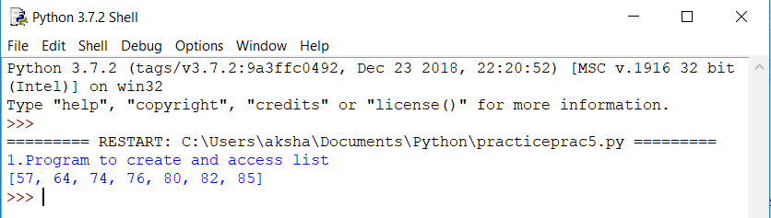

**2) Program to demonstrate the use of various list operations.**

Add : lists can be added i.e. concatenated using + operator as : list1+list2

Replication : lists can be replicated using * operator as : list_ name *n

Slicing : slice operator ([ ]) can be used to access the part of the list as : list_name[ START,STOP,STEPS ]

Append : inserts the value after the last index of list.

Delete : deletes the value of a certain index number.

Update : you can update the value at the given index as : list_name[ index_no ]=new value.

print("2.Progrm to demonstrate various list operation")

print("Add")

list1=[57,64,74,76,80,82,85]

list2=[5,6,7,6,8,2,8]

b=list1+list2

print(b)

print("Replicate")

list1=[57,64,74,76,80,82,85]

c=list1*4

print(c)

print("Slicing")

list1=[57,64,74,76,80,82,85]

t=list1[1:4]

print(t)

print("Updating a list")

list1=[57,64,74,76,80,82,85]

p=list1[4]=74

print(p)

print("Append")

list1=[57,64,74,76,80,82,85]

list1.append(100)

print(list1)

print("Delete")

list1=[57,64,74,76,80,82,85]

del list1[4]

print(list1)

**OUTPUT:**

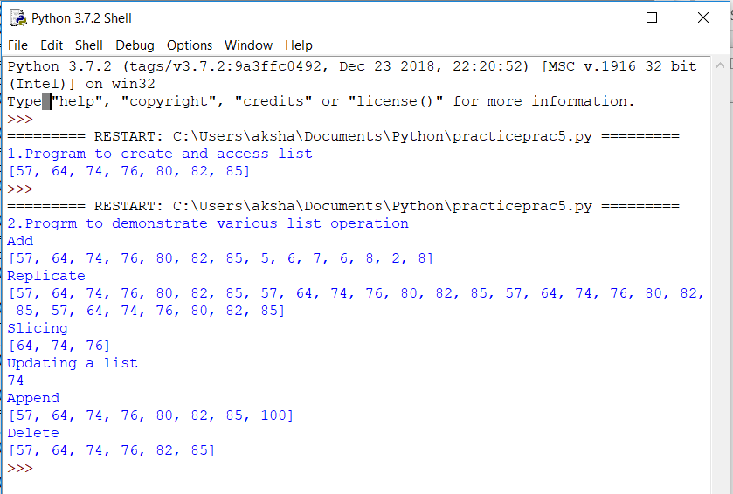

**3) Program to demonstrate the use of various functions and methods.**

Max() function : it returns the maximum value of the list.

Min() function : it returns the minimum value of the list.

len() function : it returns the length of the list i.e. no of items present in the list.

cmp() function : it returns 0 if the two lists given as parameter are same else returns -1.

print("3.Program to demonstrate the use of functions and methods")

print("Max")

list1=[57,64,74,76,80,82,85]

print(max(list1))

print("Min")

list1=[57,64,74,76,80,82,85]

print(min(list1))

print("len")

list1=[57,64,74,76,80,82,85]

print(len(list1))

print("compare")

a=[57,64,74,76,80,82,85]

b=[58,64,74,7,80,8,85]

print(cmp(a,b))

**OUTPUT:**

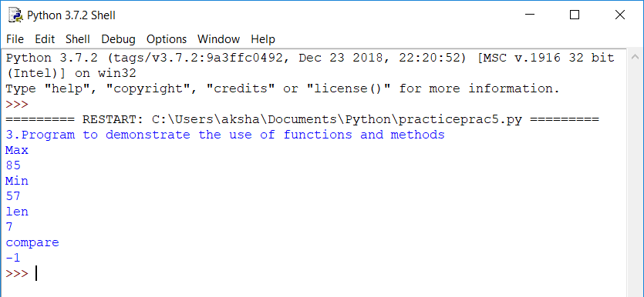

**4) Program to demonstrate the use of various list functions.**

Index(obj) function : Returns the lowest index in list that obj appears.

Count(obj) function : Returns count of how many times obj occurs in list.

Pop(obj) function : Removes and returns last object or obj from list.

Insert(index,obj) function : Inserts object obj into list at offset index.

Extend(seq) function : Appends the contents of seq to list.

Reverse() function : Reverses objects of list in place.

Sort( [func] ) function : Sorts objects of list, use compare func if given.

Remove(obj) function : Removes object obj from list.

print("4.program to demonstrate the use of inbuilt functions")

print("index")

list1=[57,64,74,76,80,82,85]

u=list1.index(74)

print(u)

print("count")

list1=[57,64,74,76,74,82,74]

e=list1.count(74)

print(e)

print("pop and pop(index)")

list1=[57,64,74,76,80,82,85]

e=list1.pop()

print(e)

print("pop and pop(index)")

list1=[57,64,74,76,80,82,85]

e=list1.pop(4)

print(e)

print("insert")

list1=[57,64,74,76,80,82,85]

list1.insert(4,'A')

print(list1)

print("Extend")

list1=[57,64,74,76,80,82,85]

list2=[57,64,74,76,80]

list1.extend(list2)

print(list1)

print("reverse")

list1=[57,64,74,76,80,82,85]

list1.reverse()

print(list1)

print("remove")

list1=[57,64,74,76,80,82,85]

list1.remove(80)

print(list1)

print("Sort")

list1=[5,1,7,9,43,28,18]

list1.sort()

print(list1)

**OUTPUT:**

